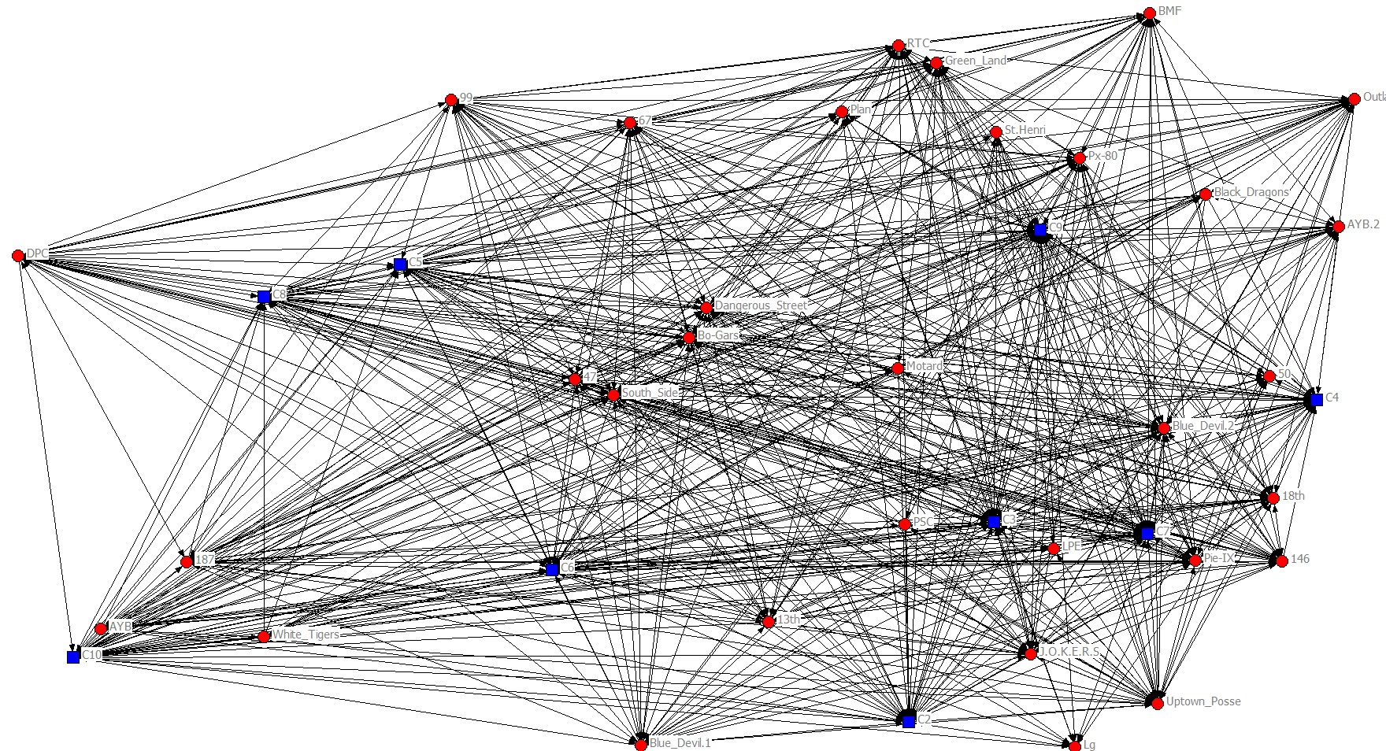

*Girvan-Newman visualization of communities. Community are designated as C1-C10 and are colored by Girvan Newman grouping.*

